Bullet chart + Bar chart is used to compare one value, represented by a horizontal bar, to another value, represented by a horizontal bar, and relate those to qualitative ranges.

It has the options to customize the visual as a multi bar chart too

Scenario 1: Bullet + Bar chart

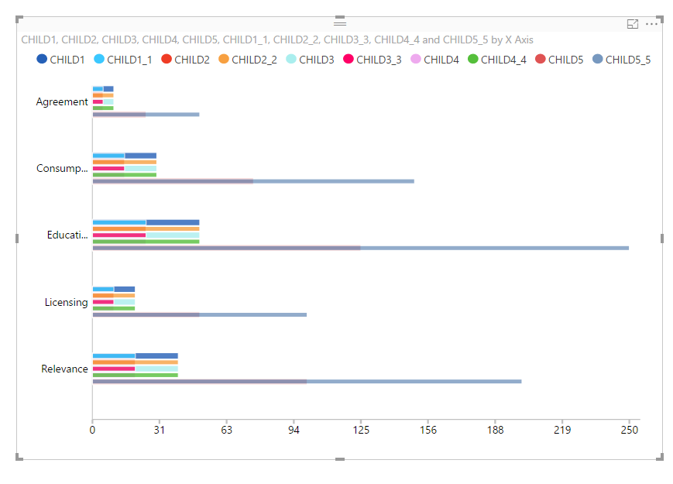

Fig. 1. Bullet + Bar chart

Scenario 2: Multi Bar chart

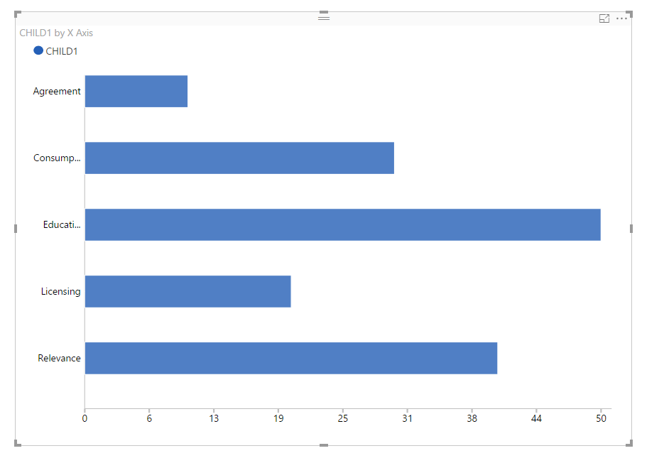

Fig. 2. Multi Bar chart

Configurations:

1. Legends:
   1. Enable: To enable legends
   2. Enable click: To make legend clickable for showing/hiding some values by clicking on legends
2. Data Colors: To set colors for bars and bullets
3. X Axis:
   1. Enable Labels: To show/hide labels on X Axis
   2. Font Size: To set font size of X Axis labels
   3. X Axis Label Color: To set color for X Axis labels
4. Y Axis:
   1. Enable Labels: To show/hide labels on Y Axis
   2. Font Size: To set font size of Y Axis labels
   3. Y Axis Label Color: To set color for Y Axis labels

Scenario 3: Modeling in Bar chart having one bar field

When there is a single bar, x-axis labels and tool tip on bars show the same Modeling format.

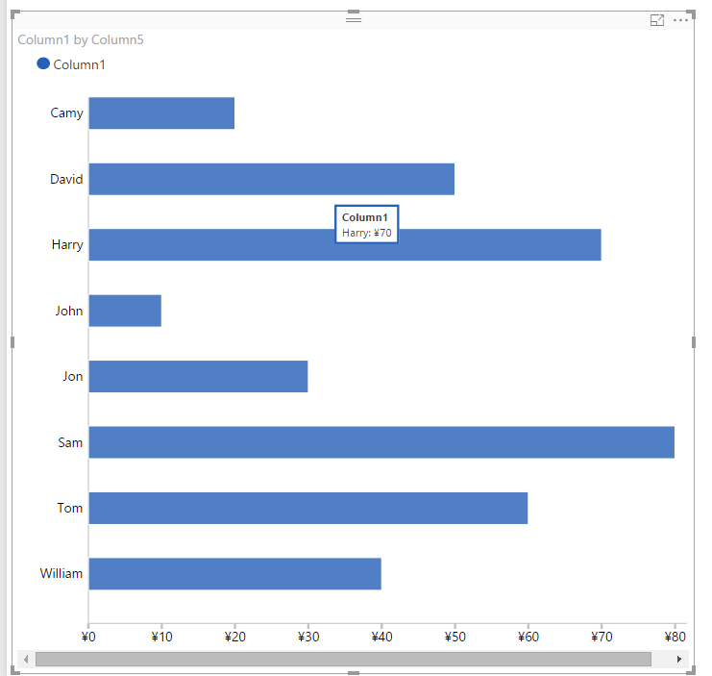

Fig. 3. Modeling in Bullet + Bar chart

Scenario 4: Modeling in Bar chart having multiple bar fields

When we have multiple bars, or mix of bars and bullets, x-axis labels will show Modeling format used by first bar and all the bars and bullets will show their own Modeling format on their tool tip.

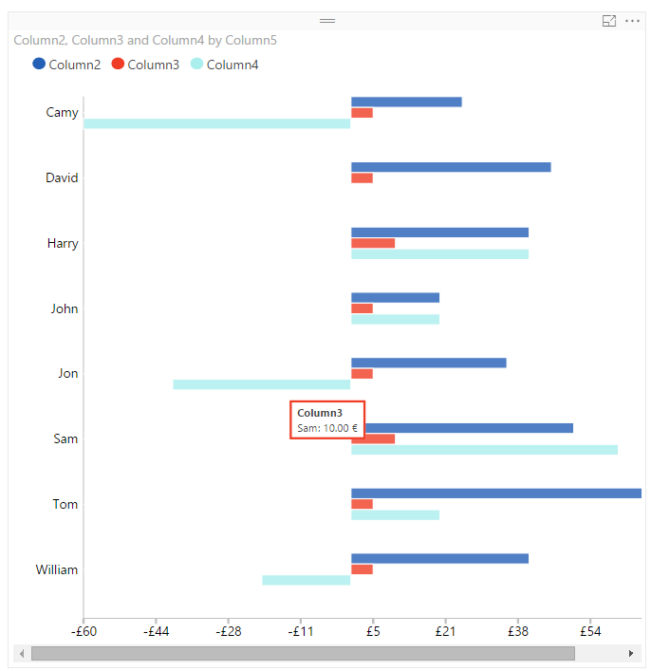

Fig. 4. Modeling for multiple bars in Bullet + Bar chart